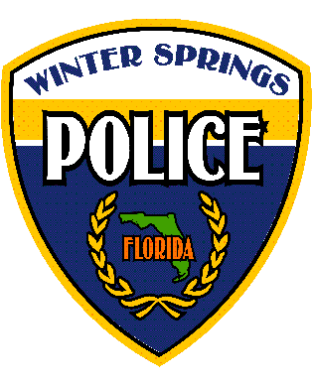In consideration of being permitted to participate in the Women’s Personal Safety Course (“Activity”), located at 300 North Moss Road, Winter Springs, FL 32708 (“Facility”), I _______________________________ hereby assume all risk of accidents, illness, personal injury, death and property damage or loss, from whatever causes, which is suffered by my child(ren) as a result of my child(ren)’s participation in the Activity within the Facility. In exchange for my child(ren)’s participation in the Activity, I hereby release the City of Winter Springs and its agents, including the Chief of Police, or his officers, employees, agents and servants from any and all liability, claims, demands, actions, and causes of action whatsoever, including negligence, arising from such participation in the Activity. This Release and Hold Harmless Agreement includes, but is not limited to, waiver of all claims, suits, and causes of action based upon the negligent or tortious acts or conduct of the City of Winter Springs, its agents, officers, employees. In addition, this Release and Hold Harmless Agreement further includes waiver of all claims, suits, and causes of action against the City of Winter Springs, its agents, officers, and employees arising from the negligent or tortious acts of other participants in the Activity, who may act in a negligent or intentionally wrongful manner and contribute to my minor child(ren)’s injury or death. The City assumes no responsibility for the actions or omissions of any participant in the Activity.

WINTER SPRINGS POLICE DEPARTMENT

**Release and Hold Harmless Agreement**

**(Child Participant)**

I (individually and on the behalf of any spouse, children, relatives, beneficiaries, estate, personal representative, successors, assigns, and all persons or entities which may derive a claim through me) further agree to indemnify and hold harmless said City of Winter Springs, Chief of Police, or his officers, employees, agents and servants from any liability and expense, including reasonable attorney’s fees, in connection with any and all claims, demands, damages, actions, causes of action, and suits in equity of whatever kind or nature, including claims for personal injury, property damage, equitable relief, or loss of use, arising directly or indirectly out of or in connection with, my minor child(ren)’s participation in the Activity.

**It is further understood and agreed by me that the City of Winter Springs shall screen all applicants for the Activity with a warrant and records check conducted through the NCIC/FCIC.**

**I KNOWINGLY, WILLFULLY, FULLY AND COMPLETELY ASSUME ANY AND ALL RISKS AND LIABILITY ASSOCIATED WITH MY CHILD’S PARTICIPATION IN THE ACTIVITY WHETHER OR NOT SAID RISKS ARE EXPRESSLY OR IMPLIEDLY STATED HEREIN. THE CITY OF WINTER SPRINGS AND ITS EMPLOYEES, AND AGENTS ARE NOT RESPONSIBLE FOR ANY INJURIES OR DEATH WHICH MAY OCCUR TO MY CHILD BEFORE, DURING, OR AFTER MY PARTICIPATION IN THE ACTIVITY.**

**I have fully read and fully understand the foregoing and in consideration of being allowed to participate in the Activity, I fully agree to the foregoing terms and conditions set forth herein. Participation in the Activity can be denied or terminated for any or no cause by the assigned officer, Supervisor, or Chief of Police at any time in the sole discretion of a Winter Springs Police official.**

__________________________ ___________________________ ____/____/____

Minor Participant's Name (please print) Minor Participant's Signature Date

I am the natural guardian of _______________________, a minor, and I am authorized to and hereby execute this agreement upon his or her behalf.

__________________________ ___________________________ ____/____/____

Natural Guardian/Participant Name (print) Natural Guardian/Participant Signature Date

NATURAL GUARDIAN DRIVER’S LICENSE________________________________________________________

NATURAL GUARDIAN DATE OF BIRTH____/____/____

RESIDENTIAL ADDRESS (No P.O. Boxes)

MINOR DATE OF BIRTH____/____/____

MINOR ADDRESS (if different) (No P.O. Boxes)